

1. Storage Blobs
2. Controlling Access to Storage Blobs and Containers
3. Configuring Azure Storage Accounts
4. Azure Files

Azure storage can store 4 types of files:

* object storage, - store the information in binary form
* table storage(non-relational),
* Queue storage,
* Files

Row storage is a storage which can be mounted anywhere and does not have file system.

Object storage – blobs-information stored in binary form –used as object

Blobs are divided into 4 types:

Page – used for random read write – eg. vhd

Block – used for storing information for longer duration, used as backup

Append – used for append operation (log files) – size 195 gb

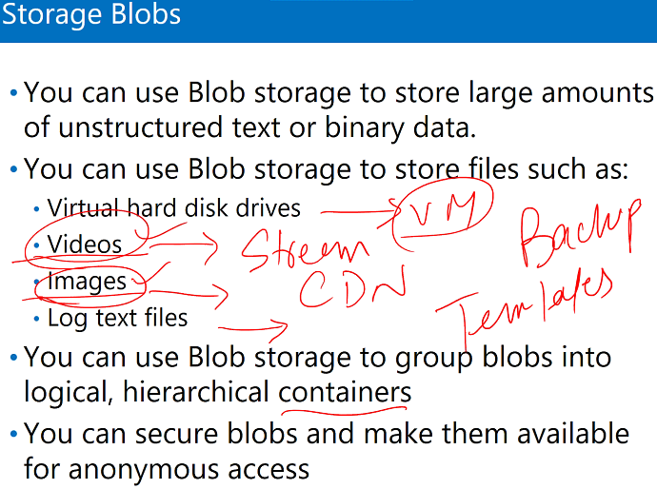

Four types of Storage Services:

1. Create Storage Account

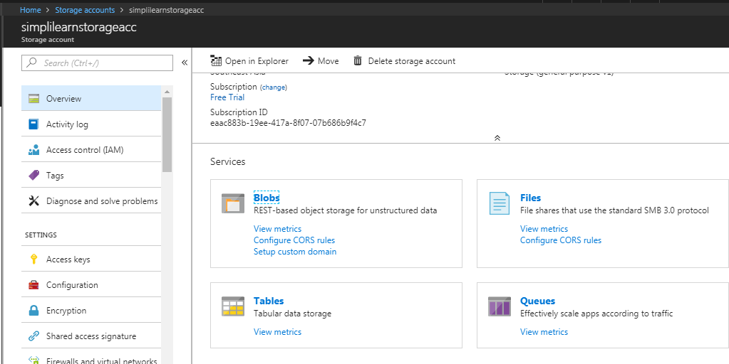

There are three local copies for our data in zone. But these files are not for backup and restore but for redundancy.

Let suppose Microsoft have one region and have two rack with multiple server. Microsoft takes care of data so that we don’t lose our data. So it will keep one copy on one server and one on another server and last one on another server.

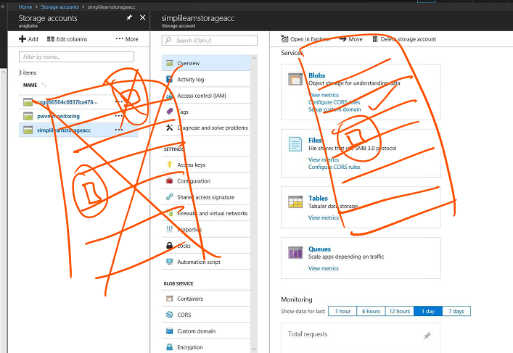

1. Go to Blobs
2. Create Container

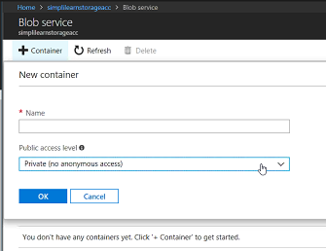

1. Open container
2. Upload any file

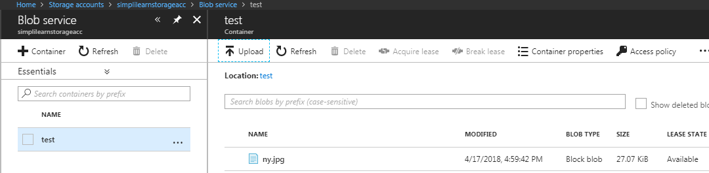

**Container**

We can have private (don’t have any access apart from azure services but we can grant access using access key)

And public container.

**To get Access to private containers:**

1. Access key : can connect to the information using access key, give complete access of data

* Key 1
* Key 2

1. Shared key signature: give more granule access where I can choose on what I want to give access of.

SAS and Access key uses same key which is inside Access key.

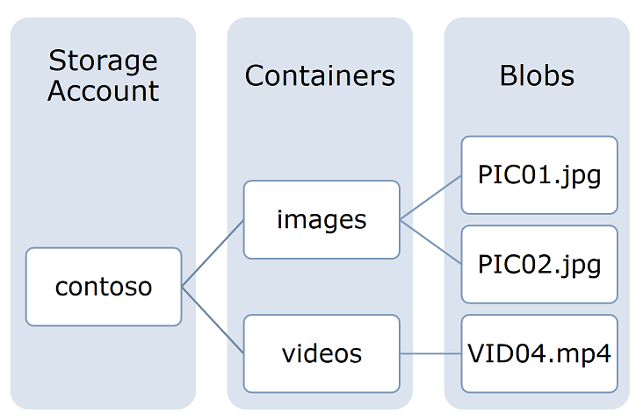

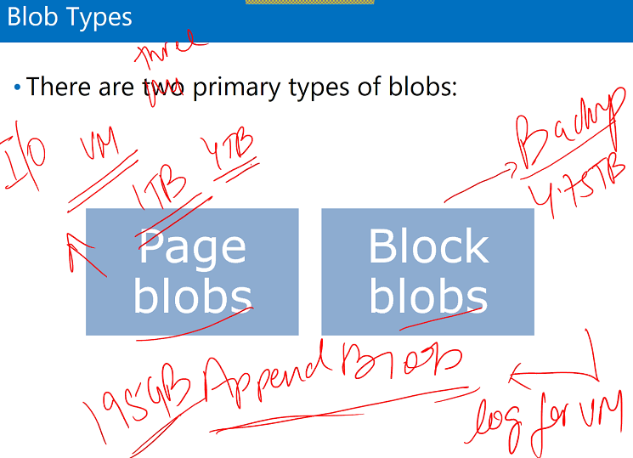

**Append Blobs**: they are useful for login scenarios.

Maximum = 195 GB

**Block Blobs:** Documents and media files. Used for backup

Maximum = 4.75 TB

**Page Blobs:** Used for I/O. Used on VM. More expensive

Maximum = 4 TB

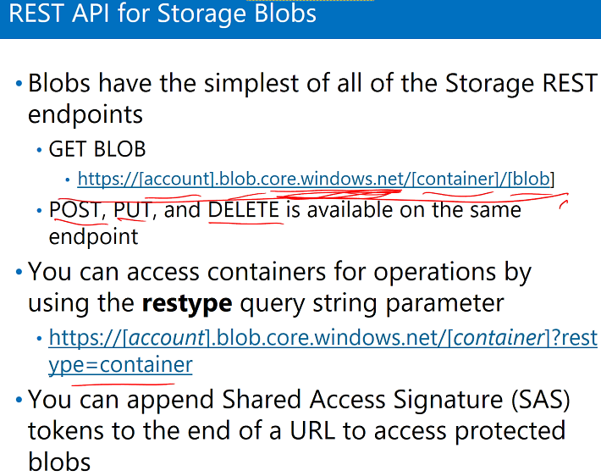

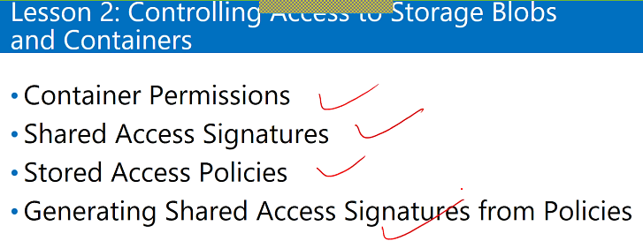

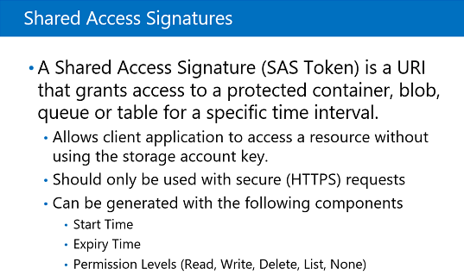

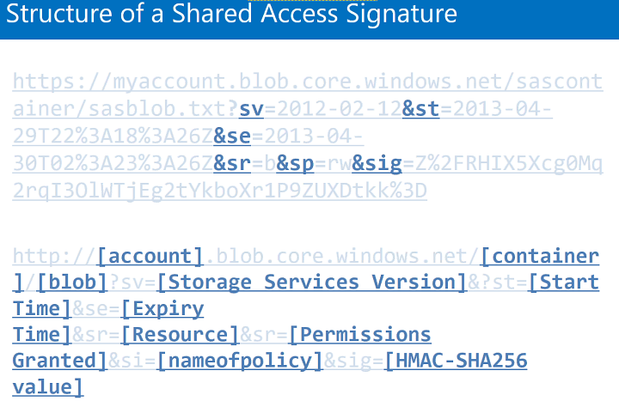

Labs:

1. Go to storage account
2. Open shared access Signature
3. Set time interval
4. Click generate SAS

Every access has separate token. SAS can give access to complete storage. Whereas SAP gives granule access

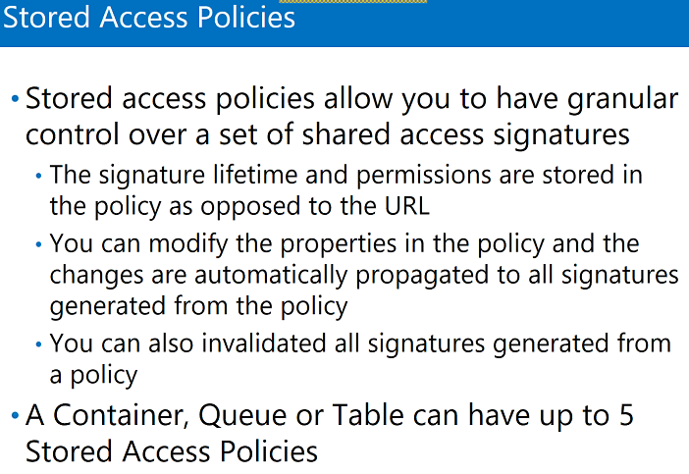

How to use RestAPI to connect to Azure Storage to store data in there:

1. VS create new project with **console app**
2. Tools – Add few packages - WindowAzure.storage
3. Get the Access Key (connection string )so that my VS connects to storage account which is in Azure

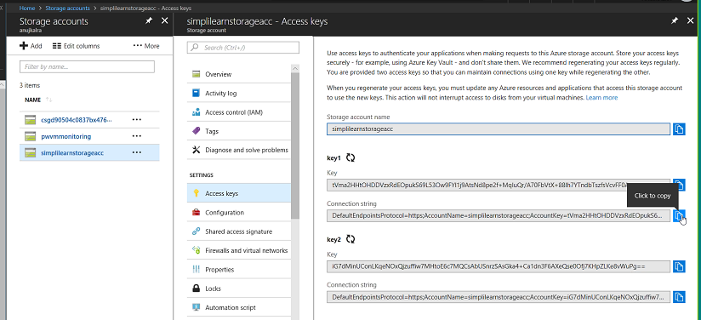

1. Copy the Access key and add here:

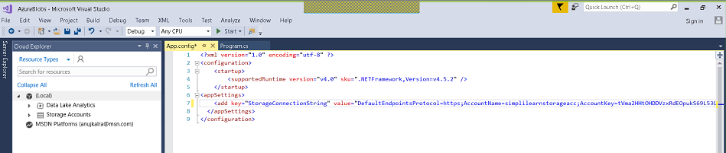

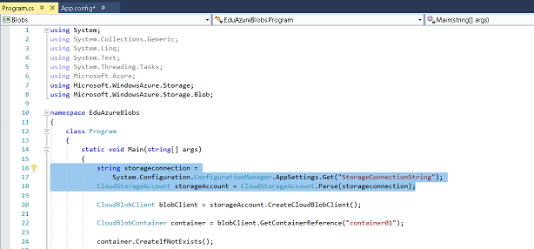

1. Add reference – system Configuration
2. Create the container

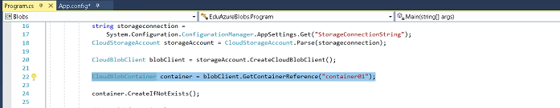

1. Once the container is created I need to upload a blob or file in there.

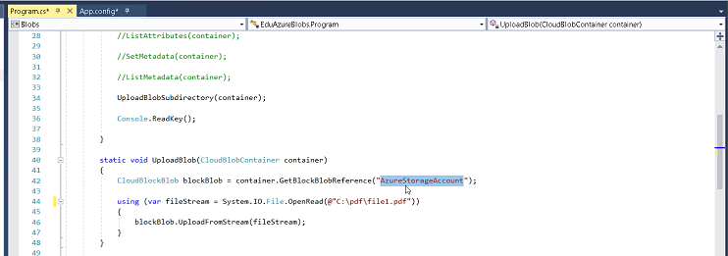

1. Listing and changing the metadata

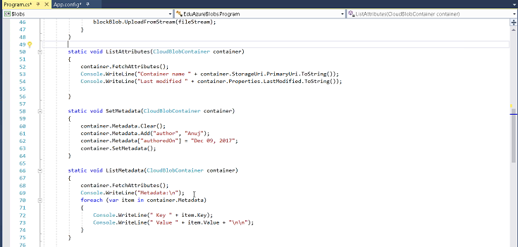

1. Coping the information from the container and making another copy of it, creating structure directory like parent directory, child directory etc., and then I am coping another file.

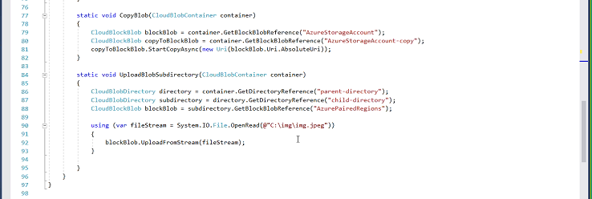

1. App config. We just have to paste the Azure Connection String.

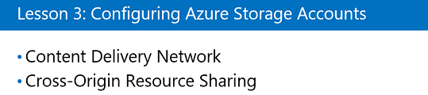

Content Delivery Network: it’s a collection of local server.

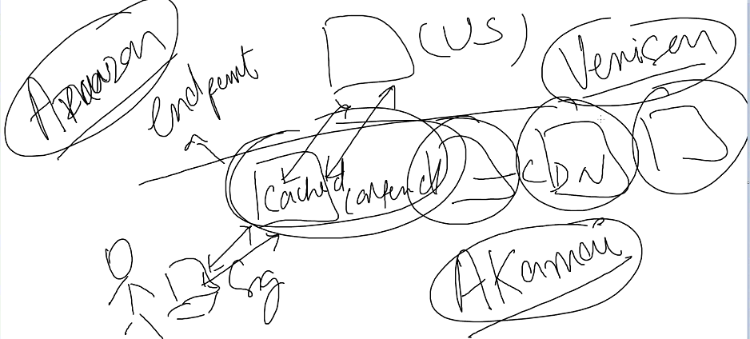

Amazon, Venisen, Akamai are the companies which own these Local server( CDN ), and they cached (store data) the content from main server to local server at the endpoint then they deleiver it to users.

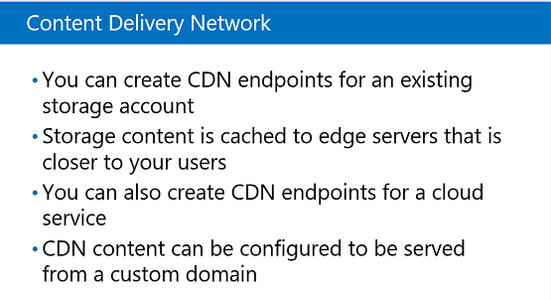

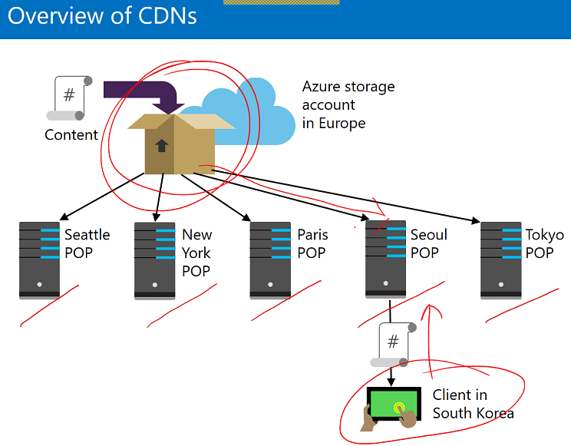

The content will be copied from storage to Seoul POP.

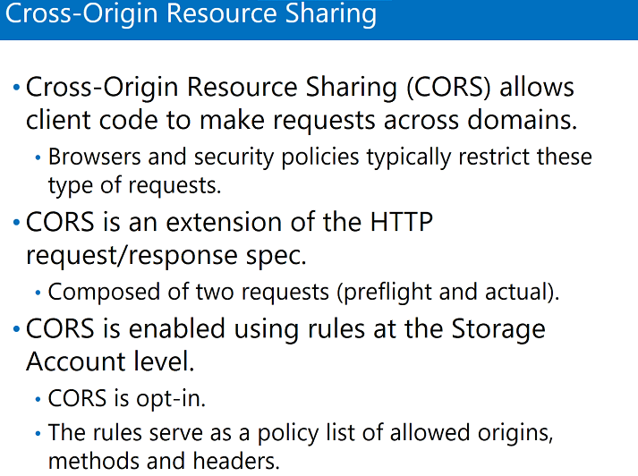

CDN Lab:

We cannot use private container with CDN.

Create Storage which will act as server for the files

1. Create storage
2. Select Blobs and create public container
3. Upload a file
4. Inside the container, click on the file
5. Copy the URL and open in browser

Configure CDN which will act as local server which user can access.

1. Go to CDN profile
2. Create new CDN

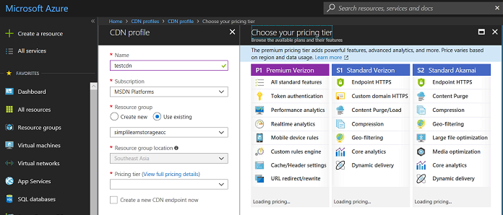

1. Add endpoint

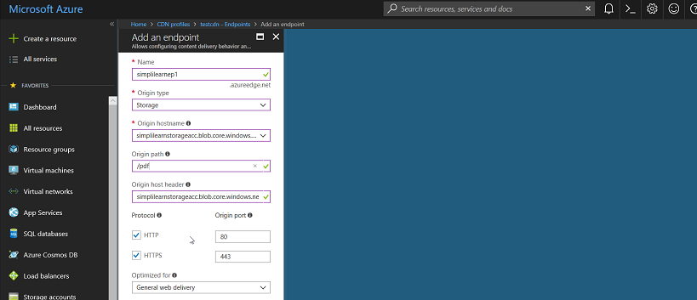

To check where actually my Blob is, like I created Storage and uploaded my file in container (it will act as server)

1. Go to Blob – copy URL
2. CMD – ping
3. Check the IP Address

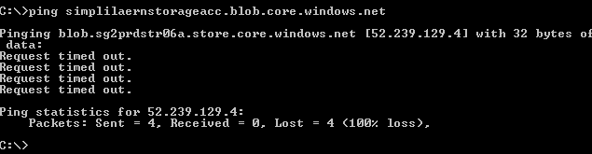

1. Check which country this IP address is

My Blobs is in Singapore

Now will access the file from the endpoint which we created for the CDN i.e. we will not access it directly from server.

1. Open CDN
2. Open Endpoint
3. Copy the URL (End point hostname)
4. Browse the URL





1. Check the IP Address

Accessing the same file from a different CDN account, I can also access from storage, Accessing from CDN, its fetching from storage and storing in the nearest CDN.

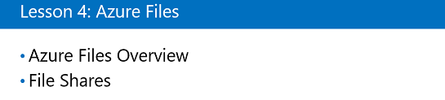

Lab:

1. Open storage
2. Open File Shares
3. Click on connect and connect to local machine
4. Copy the link
5. Open CMD and paste the link
6. Run it
7. Open window upload the file and can see that in File shares on azure portal.

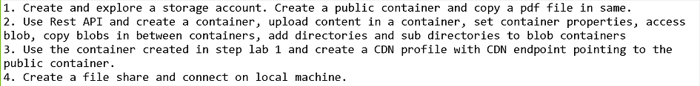

1. Storage is like URL based i.e. unique name
2. Deployment mode

Three types

1. Account type- resource or classic
2. Performance – stander and premium
3. Replication – 4 types

* Local – 3 copies on local data center
* Zone – two location in same region – it will save 3 copies in any datacenter(any location) in the region
* Geo replication – save the information to the nearest datacenter - pair read and write copies – 6 copies , 3local and 3 geo workspace
* Read only Geo – save information in pair – 6 copies, 3 copies read only and 3 copies read and write in local

1. Secure transfer – by default disabled like encryption

